Title of the paper
Author’s name and surname (style: Authors)
Affiliation, Institution, Address, e-mail (style: Author data)
Author’s name and surname
Affiliation, Institution, Address, e-mail
Author’s name and surname
Affiliation, Institution, Address, e-mail
Abstract (style: Abstract heading)
Abstract text, Abstract text, Abstract text, Abstract text, Abstract text, Abstract text, Abstract text, Abstract text, Abstract text, Abstract text, Abstract text, Abstract text, Abstract text, Abstract text, Abstract text, Abstract text, Abstract text, Abstract text, Abstract text, Abstract text, Abstract text, Abstract text, Abstract text, Abstract text, Abstract text, Abstract text... (style: Abstract text)
(max. 300 words)
Keywords: keyword 1, keyword 2, keyword 3, etc. (max 5 words)

Introduction (style: Title of the paragraph)
The current period is characterised by the development of the world market, which has consequences that extend deep into culture, identity, and lifestyle. Waves of cultural transformation accompany the globalisation of economic operations, a process called cultural globalisation. As a counterbalance to globalisation, there is localisation. Theoreticians regard... (style: Paragraph text)
Title of the paragraph (style: Title of the section)
The economy in a globalised world is an arena for competing cities and regions. Today, cities are drivers of social and cultural development, and as such, they have the power to stimulate themselves, as well as their regions and states, to grow and develop. To achieve a better position in a system determined by a network of global cities, they must be capable of strongly attracting the best organisations and professionals. Each of the mentioned components of the city as a product represents individual levels of the overall experience and perception of a city. The social space of the city is the frame... (style: Paragraph text)
Title of the paragraph (style: Title of the paragraph)
The popularity of this segment of tourism, as a component of the economy, has increased significantly over the last decade. Basic causes and motives are noted in the growth of interest in culture: increase of cultural capital, growth of the aged population in developed countries... (style: Paragraph text)
Title of the sub-paragraph (style: Title of the sub-paragraph)
It is essential to mention that manifestations, customs, etc., sometimes need to be altered and adapted in a manner that will bring them closer to the audience ... (style: Paragraph text)
Table 1: Table title (style: Caption, Table title)
 | Title of the column | Title of the column
Title of the row | text/value | text/value
Title of the row | text/value | text/value
Title of the row | text/value | text/value
Title of the sub-paragraph (style: Title of the sub-paragraph)
In addition to those mentioned above, the portal also contains a calendar of events that are organised and have the goal to acquaint visitors with history, tradition and local cultural characteristics... (style: Paragraph text)
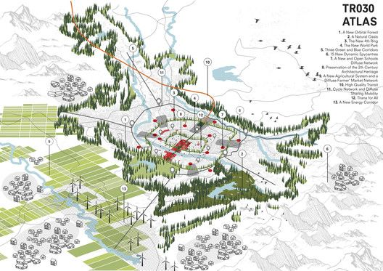
Figure 1Figure title (style: Figure title) - Authors are requested to respect the copyrights of sources that have been taken from other authors or organisations. Figure size 300dpi
Conclusions (style: Title of the paragraph)
As drivers of social and cultural development, cities stimulate themselves, regions and states to grow and develop. To achieve a better position within the system of the network of global cities, cities are orienting toward entrepreneurial activities to find ... (style: Paragraph text)
References (APA style)

Books
Smith, J. A. (2018). Understanding cultural heritage. Oxford University Press.
Taylor, M., & Brown, L. (2020). Urban transformation and public space. Routledge.

Journal Articles
Lee, C. H., & Kim, S. (2021). Social media and youth activism: A comparative study. Journal of Communication Research, 48(3), 201–218. https://doi.org/10.1177/00936502211002456

Newspaper Article (Online)
Garcia, R. (2023, May 14). Cities struggle to preserve historical identity amid modernization. The New York Times. https://www.nytimes.com/2023/05/14/cities-modernization-heritage.html

Website
UNESCO. (2022, October 11). Intangible cultural heritage and sustainable development. https://www.unesco.org/en/intangible-heritage/sustainable-development

Chapter in Edited Book
Ibrahim, L. (2019). Migration and identity in contemporary art. In D. Rowe & K. Chan (Eds.), Culture and globalization in the 21st century (pp. 89–104). Palgrave Macmillan.

The list of references should be arranged in alphabetical order. Delete Books, Journal Articles, Newspaper Articles (Online), etc.

Additional note:
The paper should be named as follows: IFAU25_section_paper_name_surname.docx
Full papers should be submitted to the following e-mail address:
2025.ifau@gmail.com
Authors are asked to respect and adhere to established styles and a defined maximum of 8 (eight) pages for the entire paper.

Corresponding author

